**University of Saskatchewan Engineering Page**

**Future and Current Students**

* There are two different two different web pages for future and current students

Currents Student

* User Experience
  + Finding classes is easy with course description link available
  + Information such as overrides, and exceptions are also easy to find
  + Mobile friendly
  + Programs are also on the right margin making it easy to which programs
  + Minimum links which is good
  + Forms aren’t available online though
* Design
  + Appealing
  + Very straight to the point
  + Professional looking
  + Organized
* Content
  + Very information based
  + Every program has a little description on what it’s about
  + All information about the program are all in one page
  + Each program has a link to the future student page

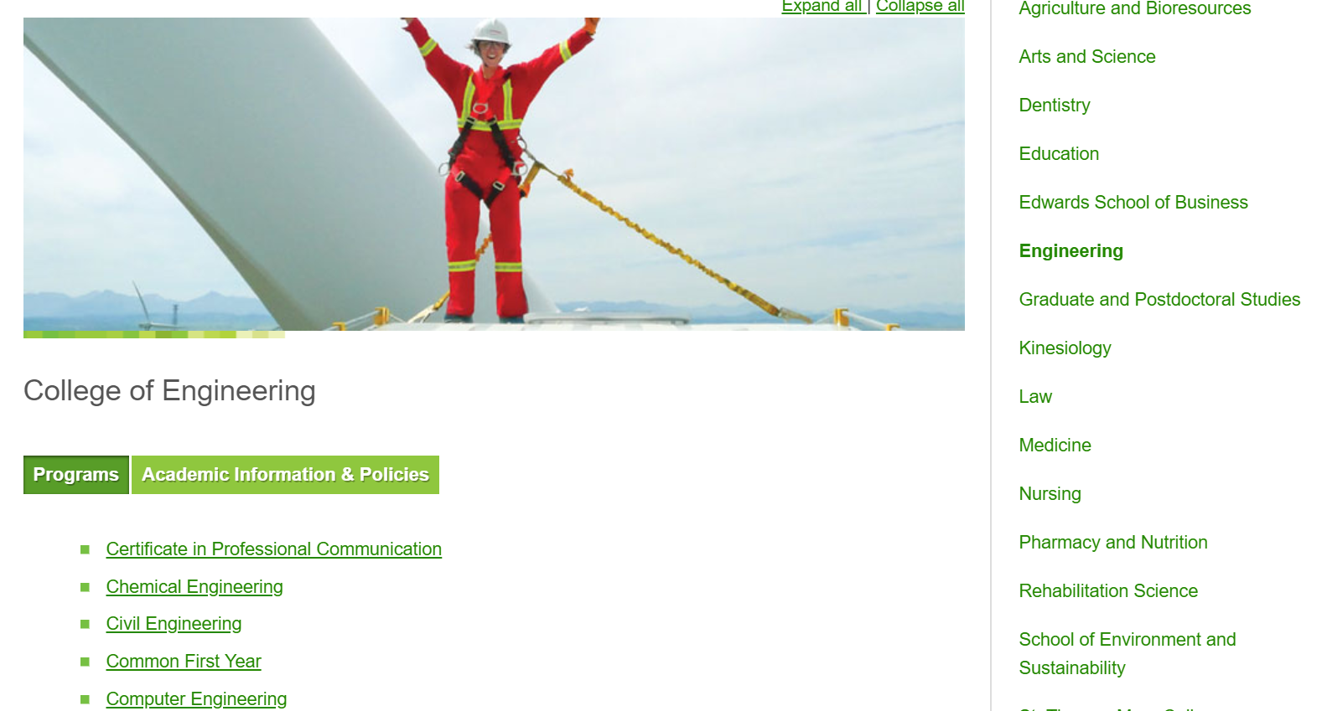

Future Student

* User Experience
  + Easy to find using the Becoming Students link in the front page of the website
  + All the basic information needed are easy to find
  + Overall good experience
  + Nothing was hard to find
  + Mobile friendly
* Design
  + Appealing
  + Very straight to the point
  + Professional looking
  + Organized
  + Link to the College of Engineering main page would have been useful on the side menu.
* Content
  + Very information based
  + Every program has a little description on what it’s about
  + All information about the program are all in one page
  + Video at the main page is a nice touch

